---------------------------------------------------------------------

-- LAB 05

--

-- Exercise 4

---------------------------------------------------------------------

USE TSQL;

GO

---------------------------------------------------------------------

-- Task 1

--

--

-- Write a SELECT statement to retrieve the custid, orderid, and orderdate columns from the Sales.Orders table. Order the rows by orderdate and orderid. Retrieve the first 20 rows.

--

-- Execute the written statement and compare the results that you got with the recommended result shown in the file 82 - Lab Exercise 4 - Task 1 Result.txt.

---------------------------------------------------------------------

---------------------------------------------------------------------

-- Detyra 1

--

--

-- Selektoni kolonat custid, orderid, dhe orderdate nga tabela Sales.Orders table.Rradhit rrjeshtat sipas orderdate dhe orderid. Nxjerr 20 rrjeshtat e pare.

--

-- Ekzekuto veprimet dhe krahaso rezultatet qe moret me rezultatet e rekomanduara ne dokumentin 82 - Lab Exercise 4 - Task 1 Result.txt.

---------------------------------------------------------------------

Select TOP(20) o.custid,o.orderdate

From Sales.Orders o

Order By o.orderdate,o.orderid

--Ekzekutimi i querisë:

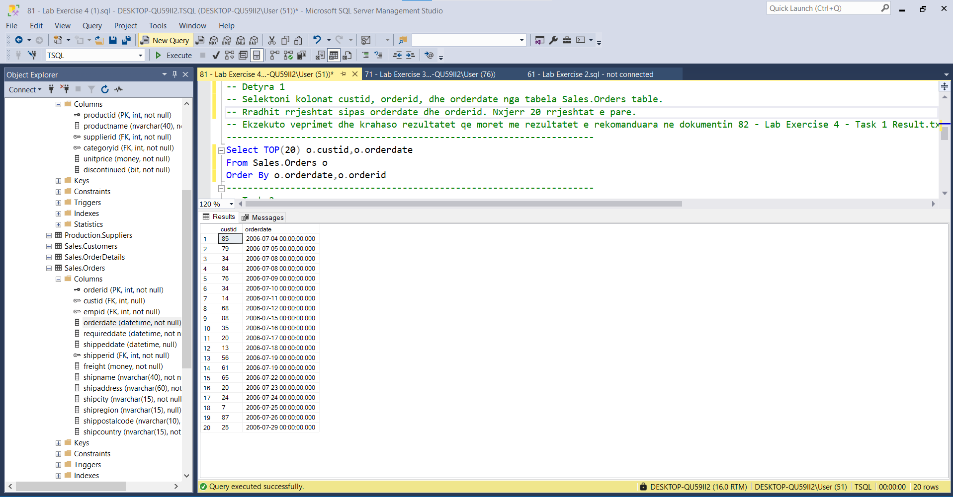

---------------------------------------------------------------------

-- Task 2

--

-- Copy the SELECT statement in task 1 and modify the OFFSET-FETCH clause to skip the first 20 rows and fetch the next 20 rows.

--

-- Execute the written statement and compare the results that you got with the recommended result shown in the file 83 - Lab Exercise 4 - Task 2 Result.txt.

---------------------------------------------------------------------

---------------------------------------------------------------------

-- Detyra 2

--

--Kopjo kodin e Detyres 1 dhe modifiko OFFSET-FETCH clause te kalosh 20 rrjeshtat e pare dhe te nxjerresh 20 rrjeshtat e tjere.

--

-- Ekzekuto veprimet dhe krahaso rezultatet qe moret me rezultatet e rekomanduara ne dokumentin 83 - Lab Exercise 4 - Task 2 Result.txt.

---------------------------------------------------------------------

Select o.custid,o.orderdate

From Sales.Orders o

Order By o.orderdate,o.orderid

OFFSET 0 ROWS FETCH FIRST 20 ROWS ONLY

\*\*\*Keshtu të dyja querite gjenrojne nga 20 rreshta dhe të njëjtin rezultat

From Sales.Orders o

Order By o.orderdate,o.orderid

OFFSET 20 ROWS FETCH NEXT 20 ROWS ONLY

---Query gjeneron 20 rreshtat pasardhës ndryshe nga query e taskut të mesiperm

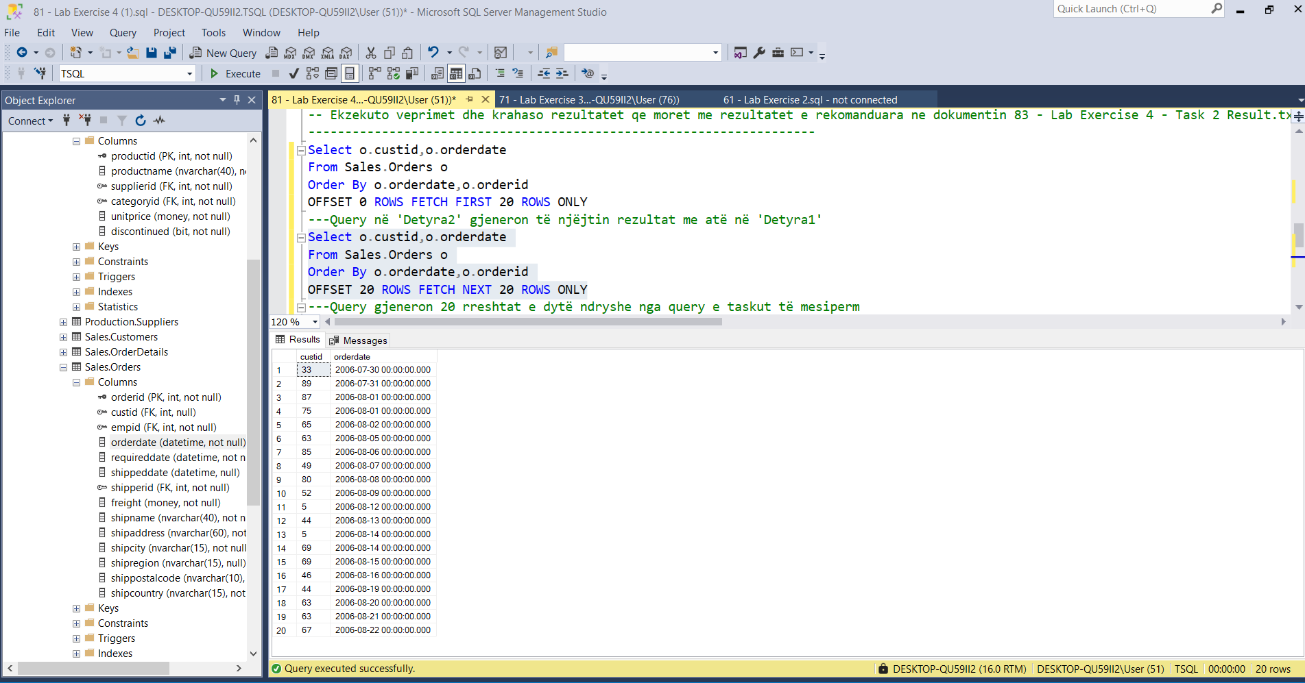

---------------------------------------------------------------------

-- Task 3

--

-- You are given the parameters @pagenum for requested page number and @pagesize for requested page size. Can you work out how to write a generic form of the OFFSET-FETCH clause using those parameters? (Do not worry about not being familiar with those parameters yet.)

---------------------------------------------------------------------

---------------------------------------------------------------------

-- Detyra 3

--

--Te jane dhene parametrat @pagenum per numrin e kerkuar te faqes dhe @pagesize per madhesine e kerkuar te faqes. Mund ta zgjidhni se si mund te shkruajme nje forme gjenerike te OFFSET-FETCH clause duke perdorur keto parametra? (Mos u shqetesoni prej faktit qe nuk jeni njohur me keto parametra.)

---------------------------------------------------------------------